
STUDENT CASE STUDY EXECUTION REPORT
Department | FED
Subject | DSA-2
Academic Year | I-III semester(2025-26)
Faculty Name | Sukanya
Student Name | Devaji Rashmika
Roll Number | 2520090152
Branch | CSIT
Course Outcome

Case Study Topic: Pune-Mumbai Expressway Dynamic-Toll Routing using Dijkstra Algorithm
Work Done Summary:
In this case study, we implemented Dijkstra’s shortest-path algorithm for the Pune-Mumbai Expressway toll network.
The network contains 7 toll plazas connected through 8 directed roads with dynamic toll costs.
We calculated the minimum toll-cost route from KIR (Kalamboli) to PUN (Pune) using a priority queue.
We also analysed the effect of dynamic toll updates caused by traffic congestion and compared naive recomputation with incremental re-routing strategies.
The final shortest toll-cost path was computed efficiently using Dijkstra’s algorithm with predecessor tracking.
Implementation Details:
- Constructed the directed weighted graph of toll plazas.
- Applied Dijkstra’s algorithm using a priority queue (min-heap).
- Maintained distance[] and parent[] arrays for shortest-path reconstruction.
- Extracted minimum-cost vertices step-by-step from the priority queue.
- Updated shortest distances through edge relaxation.
- Analysed dynamic edge-weight updates and recomputation strategies.

Result: Screenshots / Output
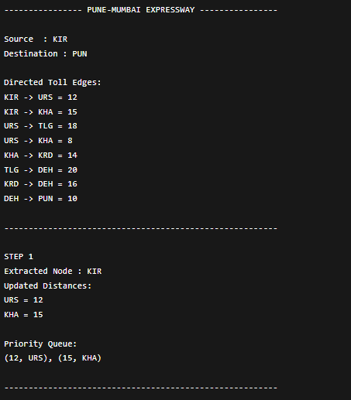
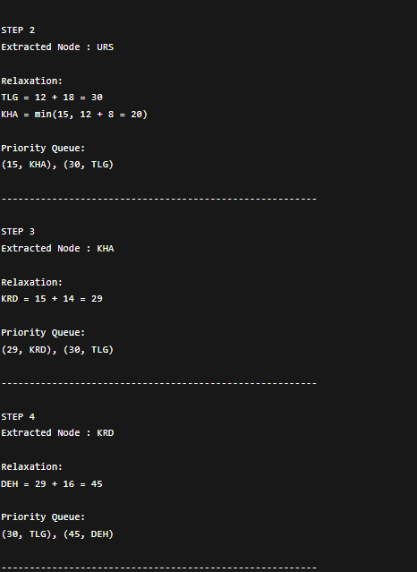

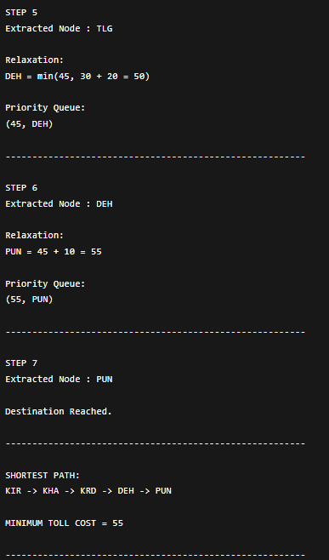

Dynamic Edge Update
Updated Edge:
URS -> TLG : 18 -> 40

Recomputed Shortest Path:
KIR -> KHA -> KRD -> DEH -> PUN
Updated Minimum Toll Cost = 55
The shortest path remains unchanged because
the URS -> TLG route becomes more expensive.
Time Complexity:
Dijkstra using Binary Heap = O((V + E) log V)
For this graph:
V = 7
E = 8

GitHub Link:
Student Signature | Faculty Signature

